# Advanced Software Engineering

## Midterm Report on Gift Finder Hackathon

**Student Details:**

Sivakumar Pothala

16148142

Computer Science

# Project Report

1. **Design**
   1. Architecture Diagram

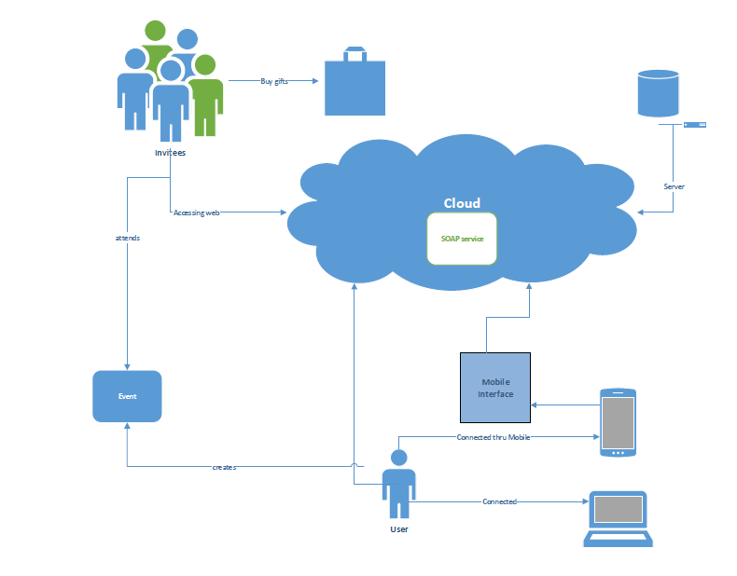

**Gift Finder Architecture Diagram**

* 1. **Class Diagram**

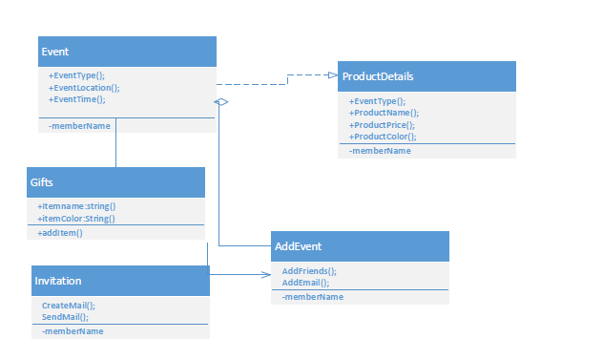

1. **Features Implemented**
   1. Web Services
      1. Your own services
      2. Existing services/APIs
   2. Database
      1. Your own data model/data sources
      2. Existing data model/data sources
   3. Mobile User Interface
      1. Your own design
      2. Existing design
2. **Include Screenshots of the Features**

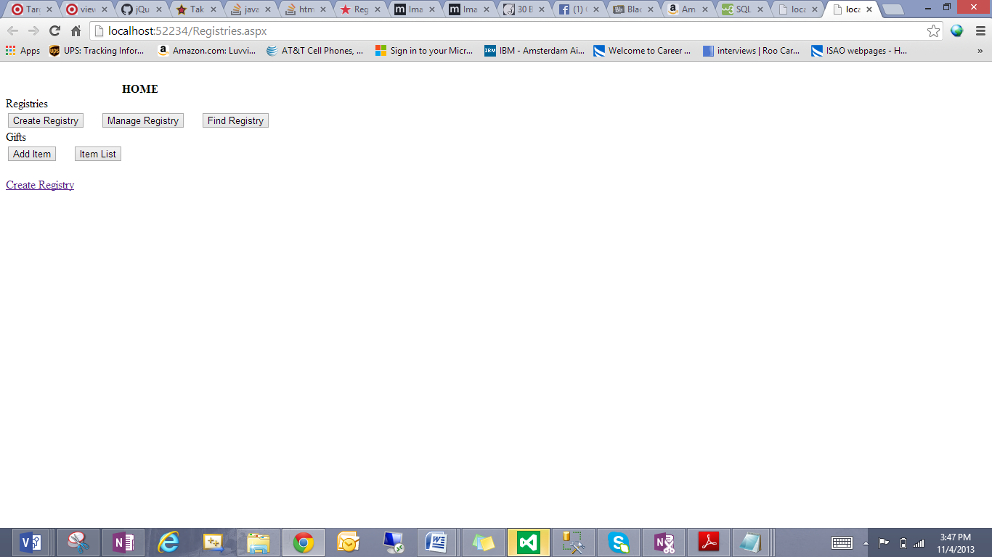

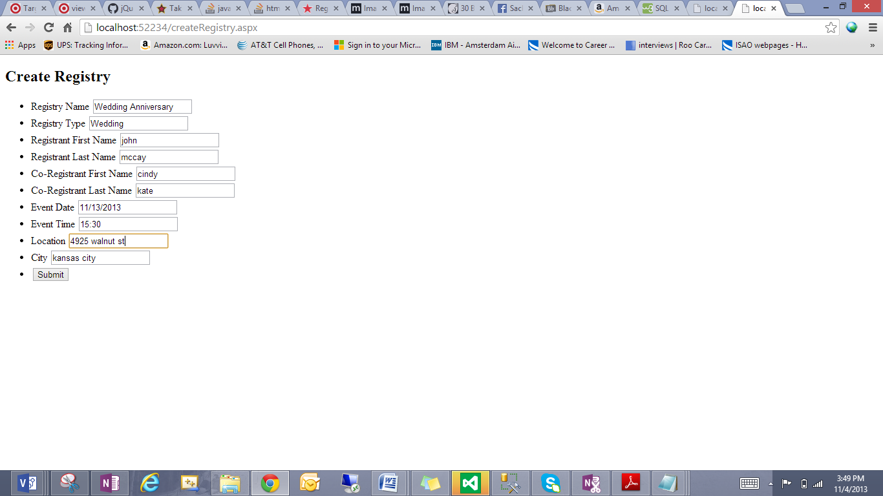

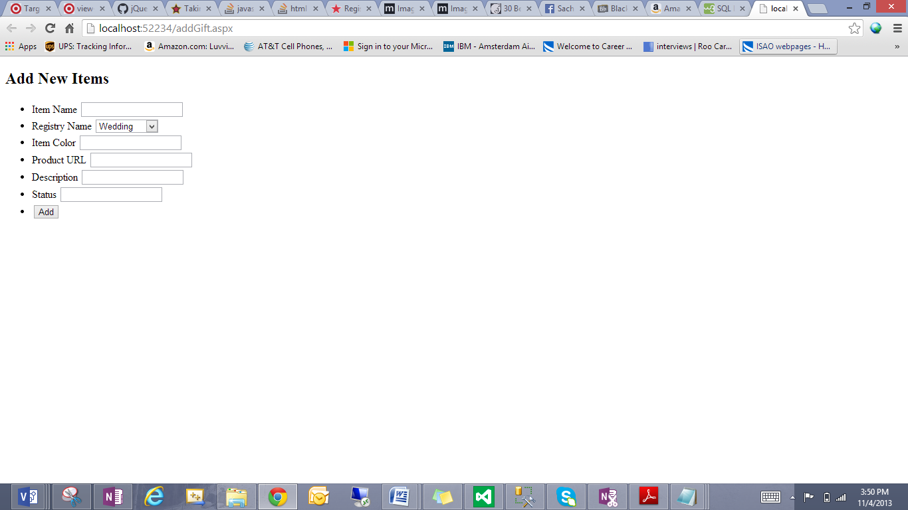

1. **Include all the Web Service and Web Site URLs**
2. **Limitations**
3. **References**

Provided in the materials and Links provided bt Dr Lee